Nominees for Board of Trustees
Student Representative
Voting closes at noon Monday 2 September 2019
(voting papers to be dropped off at the Student Office)
Belle Burdon
Hi, I’m Belle Burdon. I have been a student at WGC going on 4 years now, throughout these years I have been involved in the sports side of the school.
I have always had an interest in working with the board, partly because my Dad was on the Board at Brooklyn School and he would always talk to me and ask my opinions about the things that came up in meetings. This is what sparked my interest in doing those sorts of things. I have a big interest in what goes on in the school and I feel that I can help with student voices being heard.
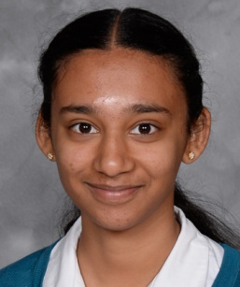 | Anoushka Divekar  Hi everyone! My name is Anoushka, and I’m a Year 12 student keen on representing you on the Board of Trustees. I have a strong interest in economics and accounting and I consider my skill set very suitable for this role.  Over my 4 years at WGC I have contributed significantly to various cultural groups such as Teal, Teal Voices, and The Reporter. I have a genuine interest in the school and want to make a difference. I’m hardworking, organised and diligent, and would love to represent all of you on the board of trustees. Thanks!
Julliette Evers
Hello! My name is Julliette Evers and I want to be your board of trustees representative in 2020. As a board representative I will be a persevering voice for the students of WGC and ensure that your opinions are considered.
I believe that student voices should be valued equally to that of adults. I am apparently a natural leader and definitely a good listener. I am passionate about environment issues, economics, community and student wellbeing. I’m ready to take on the challenge to represent you as a choice for student rep. on the board of trustees in 2020!

Maddie McHardy
Hi, I’m Maddie. I am running for the position of Student Representative on the Board of Trustees. I feel I would have a positive influence in ensuring that the wide range of student voices are heard and taken into account by those making decisions about our school.
I am passionate about our school and the students that attend it and because of this I am motivated to improve the school in any way I can. I think I would be a great Student Rep and would really appreciate your vote. Thanks!
Eva Martin
I think I would be a great Board of Trustees student representative. I am really interested in making WGC a better place.
In the position of student rep, I will listen to everyone's ideas and opinions to make a great change. I really want to ensure that a great level of communication will be available for everyone who wants to know what is happening on the board. If you vote for me I am organised and will do the job with an open mind and do my best to represent everyone in 2020!
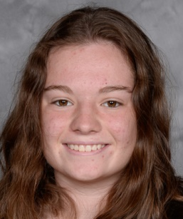 | Maddy Smith  I’ve been going to WGC for 4 years now and I really love it. I love so many aspects of it, from the community to the learning. But as we all know WGC does have some problems. I hope that in my last year as a student at WGC I would be able to help improve some of these aspects.  I am sure that I would be a great person to be your representative because I enjoy learning, especially about leadership I’ve done things similar to this before and, by being a student rep, I hope that I can improve my skills in a wider field.
Frankie Zelas
Kia Ora!
My name is Frankie Zelas and I would love to be the student representative on the board of trustees. I am in Year 12 and take Geography, German, Maths, English, Biology and Economics. I have gained skills that I think would make me a great representative through my experiences being involved in extra-curricular activities such as being a leader of the WC & WGC Jazz band, being involved in social sports teams, being a German Language Associate and many more great experiences and activities.
I have learnt how to work well and communicate with other people, I am super organised and thrive off being involved. I believe I would represent every group and individual at WGC really well as I am able to be flexible in seeing everyone’s perspectives. I promise to be enthusiastic and committed to this role. I am excited to help bring the WGC students’ opinions and ideas to the board of trustees. Thank you so much, Frankie.

